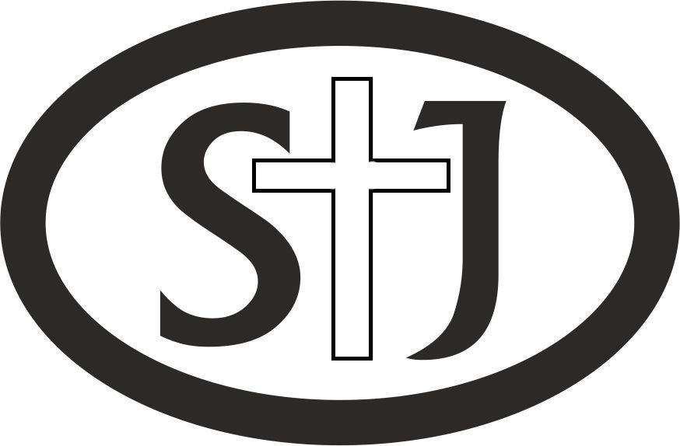
St John’s Church
Farncombe
Consent Form: St John’s Church Young People’s Group
Location: The Church Time: 3.30-5pm third Monday each month
Type of activity: Food (milkshakes, toast, fruit), discussion, games

1. Child or young person’s details
Name:
Home address:
Postcode: Telephone number:
Email: Date of birth:
2. Parent or carer’s details
Name:
Home address:
Postcode: Telephone number:
Email: Date of birth:
3. If there’s an emergency, please contact (only fill in if different from the person named above):
Name:
Telephone number:
5. Do we need to provide any extra help, for example because of a disability, or are there any activities that your child cannot participate in?

6. Do we need to know about any medical conditions or allergies? (If yes, please provide details of the condition(s) and any medication needed).

7. Is there anything else you think we should know?

St John’s Church aims to provide a safe and enjoyable experience for every child or young person. To help us do this, please note the following important information.
• All questions on the consent form must be completed and signed by the parent or carer before any child takes part.
• Parents and carers must ensure they notify us of any changes to the information given on the form.
• After the activity finishes and the young person leaves, parents and carers resume responsibility for them. If you would prefer your child not to make their own way home, you should arrange to collect them from the church.
• We cannot take responsibility for any damaged clothing and/or personal items during the activity.
• Parents and carers should ensure children have sufficient water, food, clothing, sun lotion and medication (where appropriate) for the duration of the activity.
I agree to (please tick):
□ my child taking part in the stated activity
□ St John’s Church keeping a record of this form for health and safety reasons
□ any medical treatment that my child may need to be given in an emergency
□ my child being filmed or photographed during the activity, with the possibility that these photographs/media recordings may be used for publications or marketing publicity. St John’s Church will take all steps to ensure these images are used solely for the purposes for which they are intended.) If consent is not given, St John’s Church will not use any images taken during the activity that contain the child/young person.
I understand that my child needs to follow the behaviour code and any safety rules so St John’s Church can keep them and other children safe.
Print name Signature
Date
Child or young person
I agree to (please tick):
□ taking part in the activity
□ talk to those in charge of the activity if I am not comfortable at any time so they can help me or arrange for me to do something else
□ St John’s Church keeping a record of this form so they have the information they need to keep me safe during the activity
□ receiving any emergency medical treatment that I may need
□ being filmed or photographed during the activity. I understand that the photographs or film might be used to tell other people about what St John’s Church does. If I don’t agree to this, St John’s Church will not use any images of me.
I understand that enjoying the activity and being safe means I need to follow the behaviour code and safety rules.
Print name Signature

